Task 1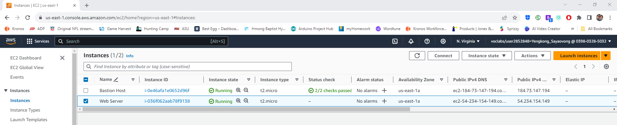

Task 2

Task 3

Task 4

Task 6

